**PRACTICAL NO.05**

**Write the program for the following:**

1. Create Web Form to demonstrate use of Website Navigation controls.

Code:

**Master Page Code:**

<%@ Master Language="C#" AutoEventWireup="true" CodeBehind="MasterPage.master.cs" Inherits="Navigation.MasterPage" %>

<!DOCTYPE html>

<html>

<head runat="server">

<title>Navigation Demo</title>

<style>

body {

font-family: Arial, sans-serif;

margin: 0;

padding: 0;

background-color: #f4f4f4;

}

#header {

background-color: #333;

color: white;

padding: 15px 0;

text-align: center;

}

#header h1 {

margin: 0;

}

}

#content {

margin: 20px;

}

#footer {

background-color: #333;

color: white;

text-align: center;

padding: 10px 0;

position: fixed;

width: 100%;

}

.treeview {

margin-top: 20px;

}

#box{

background-color:aquamarine;

color:black;

text-align:center;

padding: 10px;

}

</style>

<asp:ContentPlaceHolder ID="head" runat="server">

</asp:ContentPlaceHolder>

</head>

<body>

<form id="form1" runat="server">

<!-- Header Section -->

<div id="header">

<h1>My Website</h1>

</div>

<div id="content">

<div>

<strong>SiteMapPath:</strong><br />

<asp:SiteMapPath ID="SiteMapPath1" runat="server" />

<br />

<br />

<strong>Menu:<br /></strong>

<asp:Menu ID="Menu1" runat="server" DataSourceID="SiteMapDataSource1" >

</asp:Menu>

<br />

<br />

<strong>TreeView:</strong><asp:TreeView ID="TreeView1" runat="server" DataSourceID="SiteMapDataSource1" ShowLines="True" CssClass="treeview">

</asp:TreeView>

</div>

<asp:ContentPlaceHolder ID="ContentPlaceHolder1" runat="server">

</asp:ContentPlaceHolder>

</div>

<!-- Footer Section -->

<div id="footer">

<p>&copy; 2024 My Website. All rights reserved.</p>

</div>

<asp:SiteMapDataSource ID="SiteMapDataSource1" runat="server" />

</form>

</body>

</html>

**Sitemap Code:**

<?xml version="1.0" encoding="utf-8" ?>

<siteMap xmlns="http://schemas.microsoft.com/AspNet/SiteMap-File-1.0">

<siteMapNode url="WebForm1.aspx" title="First Page" description="This is the first page">

<siteMapNode url="WebForm2.aspx" title="Second Page" description="This is the second page" />

<siteMapNode url="WebForm3.aspx" title="Third Page" description="This is the third page" />

</siteMapNode>

</siteMap>

**WebForm1.aspx , WebForm2.aspx , WebForm3.aspx Code:**

<%@ Page Title="First Page" Language="C#" MasterPageFile="~/MasterPage.Master" AutoEventWireup="true" CodeBehind="WebForm1.aspx.cs" Inherits="Navigation.WebForm1" %>

<asp:Content ID="Content1" ContentPlaceHolderID="head" runat="server">

</asp:Content>

<asp:Content ID="Content2" ContentPlaceHolderID="ContentPlaceHolder1" runat="server">

<div id="box">

<h1>This is the first page</h1>

<p>Welcome to the first page of this demo!</p>

</div>

</asp:Content>

<%@ Page Title="" Language="C#" MasterPageFile="~/MasterPage.Master" AutoEventWireup="true" CodeBehind="WebForm2.aspx.cs" Inherits="Navigation.WebForm2" %>

<asp:Content ID="Content1" ContentPlaceHolderID="head" runat="server">

</asp:Content>

<asp:Content ID="Content2" ContentPlaceHolderID="ContentPlaceHolder1" runat="server">

<div id="box">

<h1>This is the second page</h1>

<p>Welcome to the second page of this demo!</p>

</div>

</asp:Content>

<%@ Page Title="" Language="C#" MasterPageFile="~/MasterPage.Master" AutoEventWireup="true" CodeBehind="WebForm3.aspx.cs" Inherits="Navigation.WebForm3" %>

<asp:Content ID="Content1" ContentPlaceHolderID="head" runat="server">

</asp:Content>

<asp:Content ID="Content2" ContentPlaceHolderID="ContentPlaceHolder1" runat="server">

<div id="box">

<h1>This is the third page</h1>

<p>Welcome to the third page of this demo!</p>

</div>

</asp:Content>

Output:

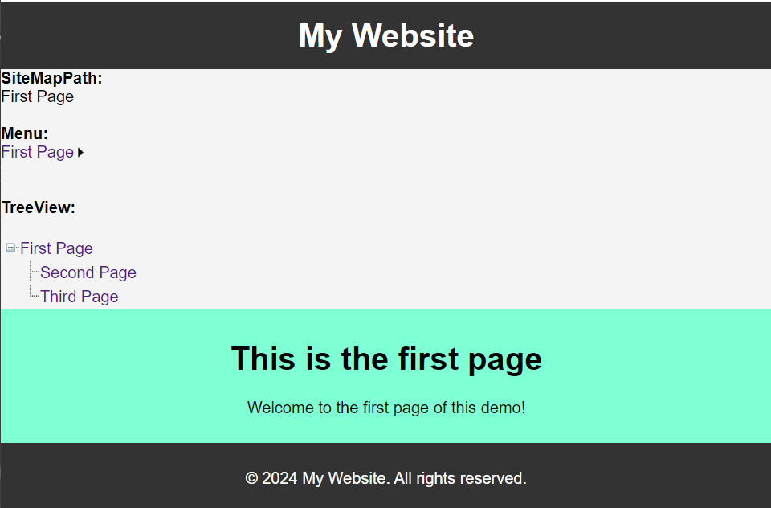 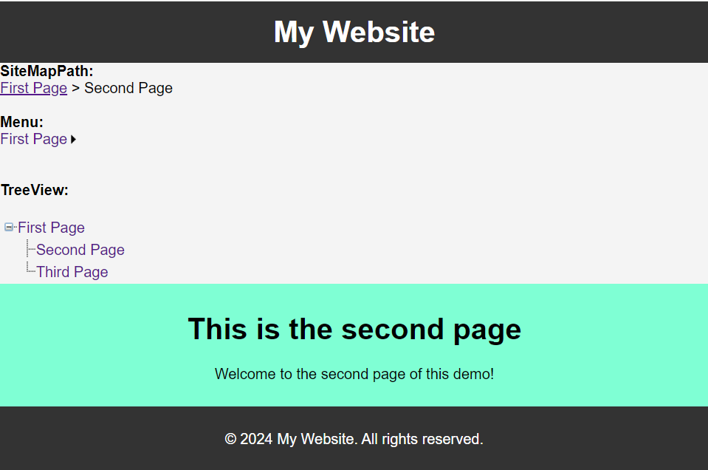

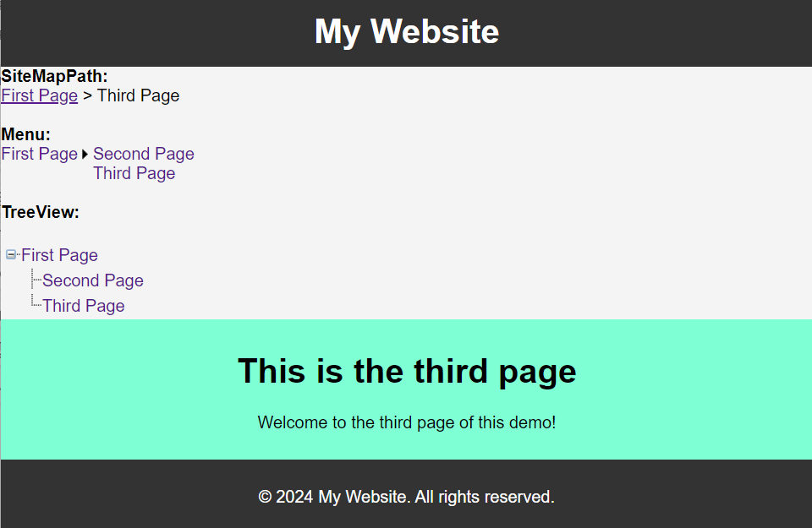

1. Create a web application to demonstrate use of Master Page and content page.

Code:

**Master Page Code:**

<%@ Master Language="C#" AutoEventWireup="true" CodeBehind="Site1.master.cs" Inherits="pract5B.Site1" %>

<!DOCTYPE html>

<html>

<head runat="server">

<title></title>

<asp:ContentPlaceHolder ID="head" runat="server">

</asp:ContentPlaceHolder>

</head>

<body>

<form id="form1" runat="server">

<div>

<header>

<h1>Welcome to My Website</h1>

<nav>

<a href="Default.aspx">Home</a> |

<a href="About.aspx">About</a> |

<a href="Contact.aspx">Contact</a>

</nav>

<hr />

</header>

<main>

<asp:ContentPlaceHolder ID="MainContent" runat="server">

</asp:ContentPlaceHolder>

</main>

<footer>

<hr />

<p>SRM College Kudal</p>

<p>&copy; 2024 My Website</p>

</footer>

</div>

</form>

</body>

</html>

**Default.aspx:**

<%@ Page Title="" Language="C#" MasterPageFile="~/Site1.Master" AutoEventWireup="true" CodeBehind="Default.aspx.cs" Inherits="pract5B.Default" %>

<asp:Content ID="Content1" ContentPlaceHolderID="head" runat="server">

</asp:Content>

<asp:Content ID="Content2" ContentPlaceHolderID="MainContent" runat="server">

<h2>Home Page</h2>

<p>Welcome to the home page of this simple website.</p>

</asp:Content>

**About.aspx:**

<%@ Page Title="" Language="C#" MasterPageFile="~/Site1.Master" AutoEventWireup="true" CodeBehind="About.aspx.cs" Inherits="pract5B.About" %>

<asp:Content ID="Content1" ContentPlaceHolderID="head" runat="server">

</asp:Content>

<asp:Content ID="Content2" ContentPlaceHolderID="MainContent" runat="server">

<h2>About Us</h2>

<p>This is the about page of this simple website.</p>

</asp:Content>

**Contact.aspx:**

<%@ Page Title="" Language="C#" MasterPageFile="~/Site1.Master" AutoEventWireup="true" CodeBehind="Contact.aspx.cs" Inherits="pract5B.Contact" %>

<asp:Content ID="Content1" ContentPlaceHolderID="head" runat="server">

</asp:Content>

<asp:Content ID="Content2" ContentPlaceHolderID="MainContent" runat="server">

<h2>Contact Details</h2>

<p>This is the Contact page of this simple website.</p>

</asp:Content>

Output:

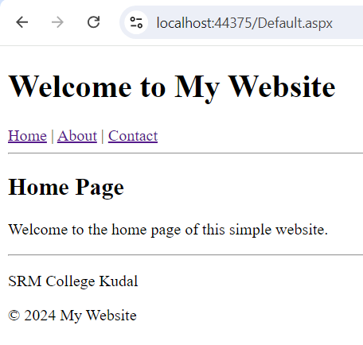 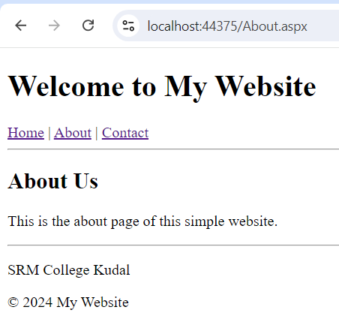

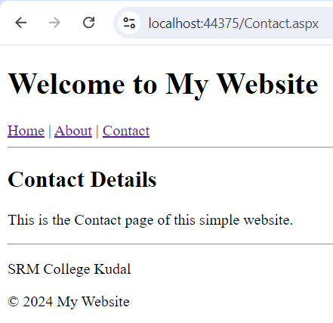

1. Create a web application to demonstrate various states of ASP.NET Pages.

Code:

**Aspx Code:**

<%@ Page Language="C#" AutoEventWireup="true" CodeBehind="WebForm1.aspx.cs" Inherits="ShoppingCartDemo.WebForm1" %>

<!DOCTYPE html>

<html xmlns="http://www.w3.org/1999/xhtml">

<head runat="server">

<title>Shopping Cart Demo</title>

</head>

<body>

<form id="form1" runat="server">

<div>

<h2>Shopping Cart Demo</h2>

<h3>ViewState</h3>

<p>Items added in this session: <asp:Label ID="lblViewState" runat="server" Text="0" /></p>

<asp:Button ID="btnAddToCartViewState" runat="server" Text="Add to Cart (ViewState)" OnClick="btnAddToCartViewState_Click" />

<h3>SessionState</h3>

<p>Items in your cart: <asp:Label ID="lblSessionState" runat="server" Text="0" /></p>

<asp:Button ID="btnAddToCartSessionState" runat="server" Text="Add to Cart (SessionState)" OnClick="btnAddToCartSessionState_Click" />

<h3>ApplicationState</h3>

<p>Total items added by all users: <asp:Label ID="lblApplicationState" runat="server" Text="0" /></p>

<asp:Button ID="btnAddToCartApplicationState" runat="server" Text="Add to Cart (ApplicationState)" OnClick="btnAddToCartApplicationState_Click" />

<br />

<asp:Label ID="lblResult" runat="server" Text="" />

</div>

</form>

</body>

</html>

**C# Code:**

using System;

using System.Web.UI;

namespace ShoppingCartDemo

{

public partial class WebForm1 : Page

{

protected void Page_Load(object sender, EventArgs e)

{

if (!IsPostBack)

{

// Initialize ViewState

ViewState["ItemsInSession"] = 0;

// Initialize SessionState

if (Session["ItemsInCart"] == null)

{

Session["ItemsInCart"] = 0;

}

// Initialize ApplicationState

if (Application["TotalItems"] == null)

{

Application["TotalItems"] = 0;

}

lblViewState.Text = ViewState["ItemsInSession"].ToString();

lblSessionState.Text = Session["ItemsInCart"].ToString();

lblApplicationState.Text = Application["TotalItems"].ToString();

}

}

protected void btnAddToCartViewState_Click(object sender, EventArgs e)

{

// Increment items in ViewState

int itemsInSession = (int)ViewState["ItemsInSession"] + 1;

ViewState["ItemsInSession"] = itemsInSession;

lblViewState.Text = itemsInSession.ToString();

lblResult.Text = "Item added to cart (ViewState).";

}

protected void btnAddToCartSessionState_Click(object sender, EventArgs e)

{

// Increment items in SessionState

int itemsInCart = (int)Session["ItemsInCart"] + 1;

Session["ItemsInCart"] = itemsInCart;

lblSessionState.Text = itemsInCart.ToString();

lblResult.Text = "Item added to cart (SessionState).";

}

protected void btnAddToCartApplicationState_Click(object sender, EventArgs e)

{

// Increment items in ApplicationState

int totalItems = (int)Application["TotalItems"] + 1;

Application["TotalItems"] = totalItems;

lblApplicationState.Text = totalItems.ToString();

lblResult.Text = "Item added to cart (ApplicationState).";

}

}

}

Output:

